Practical No. 8
1. Create a login form with username and password fields, and validate non-empty input.

MainActivity.java :
package com.techtitans.madpracticals;
import android.os.Bundle;
import android.widget.*;
import androidx.appcompat.app.AppCompatActivity;
public class MainActivity extends AppCompatActivity {
protected void onCreate(Bundle b) {
super.onCreate(b);
setContentView(R.layout.activity_main);
EditText u = findViewById(R.id.etUser);
EditText p = findViewById(R.id.etPass);
Button btn = findViewById(R.id.btnLogin);
btn.setOnClickListener(v -> {
if(u.getText().toString().isEmpty() || p.getText().toString().isEmpty())
Toast.makeText(this,"Fill all fields",Toast.LENGTH_SHORT).show();
else if(u.getText().toString().equals("DYP") && p.getText().toString().equals("login"))
Toast.makeText(this,"Login Successful",Toast.LENGTH_SHORT).show();
else
Toast.makeText(this,"Invalid Credentials",Toast.LENGTH_SHORT).show();
});
}
}

activity_main.xml :
<?xml version="1.0" encoding="utf-8"?>
<LinearLayout xmlns:android="http://schemas.android.com/apk/res/android"
android:layout_width="match_parent"
android:layout_height="match_parent"
android:orientation="vertical"
android:gravity="center"
android:padding="24dp">
<EditText
android:id="@+id/etUser"
android:layout_width="match_parent"
android:layout_height="wrap_content"
android:hint="Username"
android:layout_marginBottom="12dp"
android:padding="12dp"
android:textSize="16sp"/>
<EditText
android:id="@+id/etPass"
android:layout_width="match_parent"
android:layout_height="wrap_content"
android:hint="Password"
android:inputType="textPassword"
android:layout_marginBottom="16dp"
android:padding="12dp"
android:textSize="16sp"/>
<Button
android:id="@+id/btnLogin"
android:layout_width="match_parent"
android:layout_height="wrap_content"
android:text="Login"
android:textSize="16sp"/>
</LinearLayout>

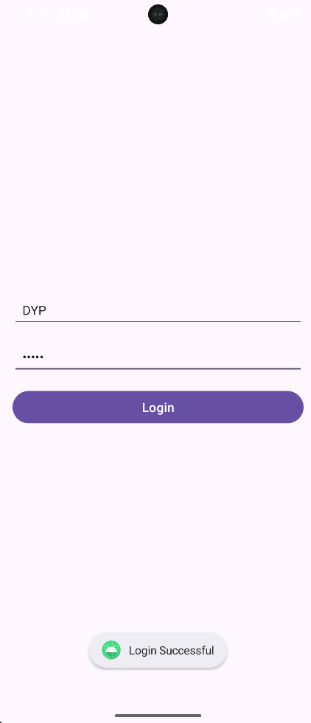
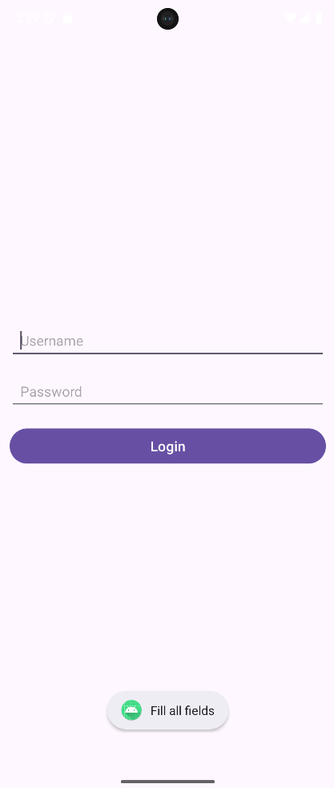

2. Add gender selection using radio buttons and display the selected gender on login.

MainActivity.java :

package com.techtitans.madpracticals;
import android.os.Bundle;
import android.widget.*;
import androidx.appcompat.app.AppCompatActivity;
public class MainActivity extends AppCompatActivity {
protected void onCreate(Bundle b) {
super.onCreate(b);
setContentView(R.layout.activity_main);
EditText u = findViewById(R.id.etUser);
EditText p = findViewById(R.id.etPass);
Button btn = findViewById(R.id.btnLogin);
RadioButton m = findViewById(R.id.rbMale);
RadioButton f = findViewById(R.id.rbFemale);
btn.setOnClickListener(v -> {
if(u.getText().toString().isEmpty() || p.getText().toString().isEmpty())
Toast.makeText(this,"Fill all fields",Toast.LENGTH_SHORT).show();
else if(u.getText().toString().equals("DYP") && p.getText().toString().equals("login"))
Toast.makeText(this,"Login Successful",Toast.LENGTH_SHORT).show();
else
Toast.makeText(this,"Invalid Credentials",Toast.LENGTH_SHORT).show();
});
btn.setOnClickListener(v -> {
if(m.isChecked())
Toast.makeText(this,"Gender: Male",Toast.LENGTH_SHORT).show();
if(f.isChecked())
Toast.makeText(this,"Gender: Female",Toast.LENGTH_SHORT).show();
});
}
}

activity_main.xml :
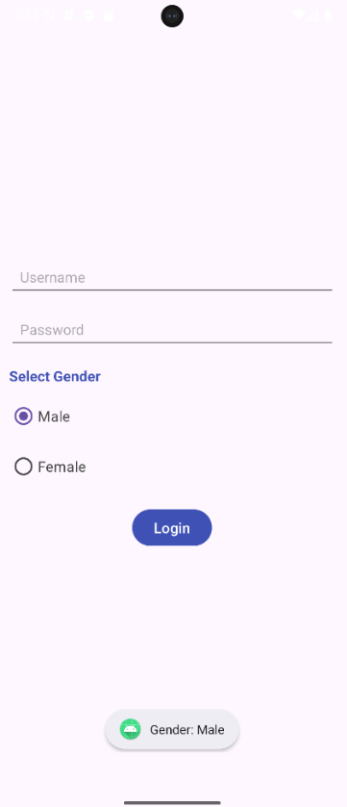
<?xml version="1.0" encoding="utf-8"?>
<LinearLayout xmlns:android="http://schemas.android.com/apk/res/android"
android:layout_width="match_parent"
android:layout_height="match_parent"
android:orientation="vertical"
android:gravity="center"
android:padding="24dp">
<EditText
android:id="@+id/etUser"
android:layout_width="match_parent"
android:layout_height="wrap_content"
android:hint="Username"
android:layout_marginBottom="12dp"
android:padding="12dp"
android:textSize="16sp"/>
<EditText
android:id="@+id/etPass"
android:layout_width="match_parent"
android:layout_height="wrap_content"
android:hint="Password"
android:inputType="textPassword"
android:layout_marginBottom="18dp"
android:padding="12dp"
android:textSize="16sp"/>
<TextView
android:layout_width="match_parent"
android:layout_height="wrap_content"
android:text="Select Gender"
android:textSize="16sp"
android:textStyle="bold"
android:textColor="#3F51B5"
android:layout_marginBottom="10dp"/>
<RadioGroup
android:id="@+id/rg"
android:layout_width="match_parent"
android:layout_height="wrap_content"
android:layout_marginBottom="20dp">
<RadioButton
android:id="@+id/rbMale"
android:layout_width="wrap_content"
android:layout_height="wrap_content"
android:text="Male"
android:textSize="16sp"
android:textColor="#444444"
android:buttonTint="#3F51B5"
android:layout_marginBottom="8dp"/>
<RadioButton
android:id="@+id/rbFemale"
android:layout_width="wrap_content"
android:layout_height="wrap_content"
android:text="Female"
android:textSize="16sp"
android:textColor="#444444"
android:buttonTint="#3F51B5"/>
</RadioGroup>
<Button
android:id="@+id/btnLogin"
android:layout_width="wrap_content"
android:layout_height="wrap_content"
android:text="Login"
android:textSize="16sp"
android:textColor="#FFFFFF"
android:backgroundTint="#3F51B5"/>
</LinearLayout>

3 .Implement a "Remember Me" checkbox and show a toast message based on its state.

MainActivity.java :
package com.techtitans.madpracticals;
import android.os.Bundle;
import android.widget.*;
import androidx.appcompat.app.AppCompatActivity;
public class MainActivity extends AppCompatActivity {
protected void onCreate(Bundle b) {
super.onCreate(b);
setContentView(R.layout.activity_main);
EditText user = findViewById(R.id.etUser);
EditText pass = findViewById(R.id.etPass);
Button btn = findViewById(R.id.btnLogin);
RadioButton male = findViewById(R.id.rbMale);
RadioButton female = findViewById(R.id.rbFemale);
CheckBox check = findViewById(R.id.chk);
btn.setOnClickListener(v -> {
if(user.getText().toString().isEmpty() || pass.getText().toString().isEmpty()) {
Toast.makeText(this,"Fill all fields",Toast.LENGTH_SHORT).show();
return;
}
if(user.getText().toString().equals("DYP") && pass.getText().toString().equals("login"))
Toast.makeText(this,"Login Successful",Toast.LENGTH_SHORT).show();
else {
Toast.makeText(this,"Invalid Credentials",Toast.LENGTH_SHORT).show();
return;
}
if(male.isChecked())
Toast.makeText(this,"Gender: Male",Toast.LENGTH_SHORT).show();
else if(female.isChecked())
Toast.makeText(this,"Gender: Female",Toast.LENGTH_SHORT).show();
if(check.isChecked())
Toast.makeText(this,"Remember Me checked",Toast.LENGTH_SHORT).show();
else {
Toast.makeText(this,"Remember Me Unchecked",Toast.LENGTH_SHORT).show();
}
});
}
}

activity_main.xml :
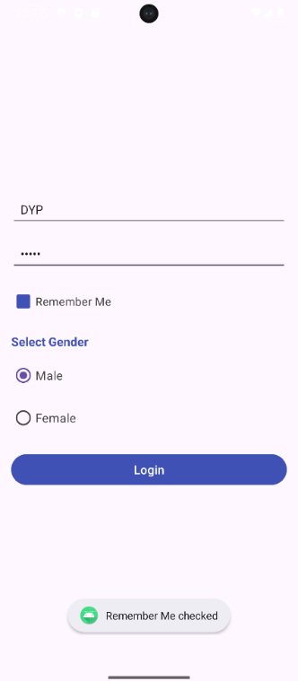
<?xml version="1.0" encoding="utf-8"?>
<LinearLayout xmlns:android="http://schemas.android.com/apk/res/android"
android:layout_width="match_parent"
android:layout_height="match_parent"
android:orientation="vertical"
android:gravity="center"
android:padding="24dp">
<EditText
android:id="@+id/etUser"
android:layout_width="match_parent"
android:layout_height="wrap_content"
android:hint="Username"
android:layout_marginBottom="12dp"
android:padding="12dp"
android:textSize="16sp"/>
<EditText
android:id="@+id/etPass"
android:layout_width="match_parent"
android:layout_height="wrap_content"
android:hint="Password"
android:inputType="textPassword"
android:layout_marginBottom="16dp"
android:padding="12dp"
android:textSize="16sp"/>
<CheckBox
android:id="@+id/chk"
android:layout_width="match_parent"
android:layout_height="wrap_content"
android:text="Remember Me"
android:textSize="15sp"
android:textColor="#444444"
android:buttonTint="#3F51B5"
android:layout_marginBottom="18dp"/>
<TextView
android:layout_width="match_parent"
android:layout_height="wrap_content"
android:text="Select Gender"
android:textSize="16sp"
android:textStyle="bold"
android:textColor="#3F51B5"
android:layout_marginBottom="10dp"/>
<RadioGroup
android:id="@+id/rg"
android:layout_width="match_parent"
android:layout_height="wrap_content"
android:layout_marginBottom="20dp">
<RadioButton
android:id="@+id/rbMale"
android:layout_width="wrap_content"
android:layout_height="wrap_content"
android:text="Male"
android:textSize="16sp"
android:textColor="#444444"
android:buttonTint="#3F51B5"
android:layout_marginBottom="8dp"/>
<RadioButton
android:id="@+id/rbFemale"
android:layout_width="wrap_content"
android:layout_height="wrap_content"
android:text="Female"
android:textSize="16sp"
android:textColor="#444444"
android:buttonTint="#3F51B5"/>
</RadioGroup>
<Button
android:id="@+id/btnLogin"
android:layout_width="match_parent"
android:layout_height="wrap_content"
android:text="Login"
android:textSize="16sp"
android:textColor="#FFFFFF"
android:backgroundTint="#3F51B5"/>
</LinearLayout>

4. Design a form that disables the login button until all fields are filled

MainActivity.java :
package com.techtitans.madpracticals;
import android.os.Bundle;
import android.text.*;
import android.widget.*;
import androidx.appcompat.app.AppCompatActivity;
public class MainActivity extends AppCompatActivity {
protected void onCreate(Bundle b) {
super.onCreate(b);
setContentView(R.layout.activity_main);
EditText user = findViewById(R.id.etUser);
EditText pass = findViewById(R.id.etPass);
Button btn = findViewById(R.id.btnLogin);
RadioButton male = findViewById(R.id.rbMale);
RadioButton female = findViewById(R.id.rbFemale);
CheckBox check = findViewById(R.id.chk);
btn.setEnabled(false);
btn.setBackgroundTintList(
android.content.res.ColorStateList.valueOf(
android.graphics.Color.parseColor("#BDBDBD")));
user.addTextChangedListener(new TextWatcher() {
@Override
public void afterTextChanged(Editable s) {
if (!user.getText().toString().isEmpty() &&
!pass.getText().toString().isEmpty()) {
btn.setEnabled(true);
btn.setBackgroundTintList(
android.content.res.ColorStateList.valueOf(
android.graphics.Color.parseColor("#3F51B5")));
} else {
btn.setEnabled(false);
btn.setBackgroundTintList(
android.content.res.ColorStateList.valueOf(
android.graphics.Color.parseColor("#BDBDBD")));
} }
@Override
public void beforeTextChanged(CharSequence s, int start, int count, int after) { }
@Override
public void onTextChanged(CharSequence s, int start, int before, int count) { }
});
pass.addTextChangedListener(new TextWatcher() {
@Override
public void afterTextChanged(Editable s) {
if (!user.getText().toString().isEmpty() &&
!pass.getText().toString().isEmpty()) {
btn.setEnabled(true);
btn.setBackgroundTintList(
android.content.res.ColorStateList.valueOf(
android.graphics.Color.parseColor("#3F51B5")));
} else {
btn.setEnabled(false);
btn.setBackgroundTintList(
android.content.res.ColorStateList.valueOf(
android.graphics.Color.parseColor("#BDBDBD")));
} }
@Override
public void beforeTextChanged(CharSequence s, int start, int count, int after) { }
@Override
public void onTextChanged(CharSequence s, int start, int before, int count) { }
});
btn.setOnClickListener(v -> {
if(user.getText().toString().equals("DYP") &&
pass.getText().toString().equals("login"))
Toast.makeText(this,"Login Successful",Toast.LENGTH_SHORT).show();
else {
Toast.makeText(this,"Invalid Credentials",Toast.LENGTH_SHORT).show();
return;
}
if(male.isChecked())
Toast.makeText(this,"Gender: Male",Toast.LENGTH_SHORT).show();
else if(female.isChecked())
Toast.makeText(this,"Gender: Female",Toast.LENGTH_SHORT).show();
if(check.isChecked())
Toast.makeText(this,"Remember Me checked",Toast.LENGTH_SHORT).show();
else
Toast.makeText(this,"Remember Me Unchecked",Toast.LENGTH_SHORT).show();
});
}
}

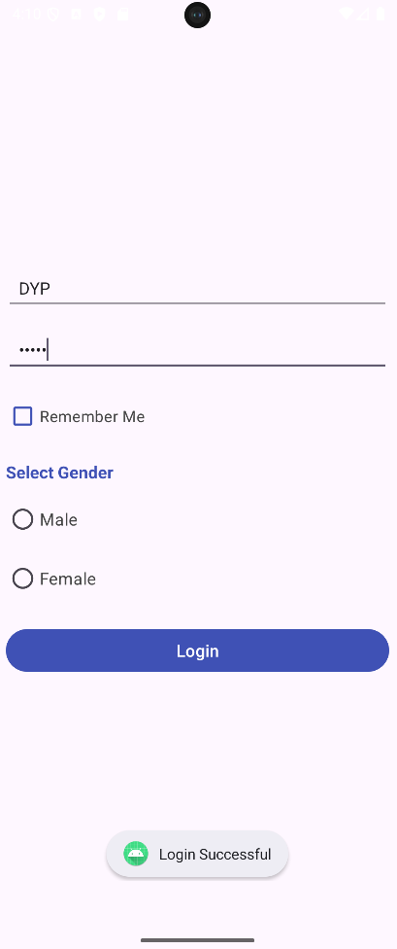
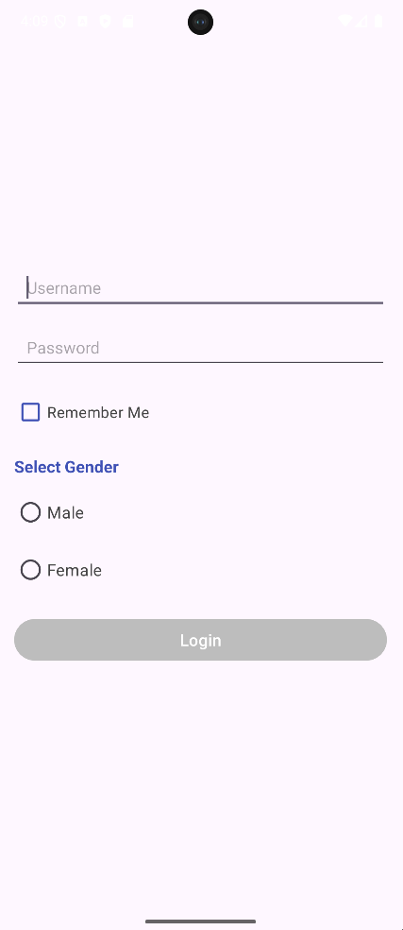
activity_main.xml :

Chnageable part only :-
<Button
android:id="@+id/btnLogin"
android:layout_width="match_parent"
android:layout_height="wrap_content"
android:text="Login"
android:textSize="16sp"
android:textColor="#FFFFFF"
android:backgroundTint="#BDBDBD"
android:enabled="false"/>

5 .Modify the form to include a progress bar that appears during login processing.

MainActivity.java :
package com.techtitans.madpracticals;

import android.os.*;
import android.text.*;
import android.view.View;
import android.widget.*;
import androidx.appcompat.app.AppCompatActivity;

public class MainActivity extends AppCompatActivity {

protected void onCreate(Bundle b) {
super.onCreate(b);
setContentView(R.layout.activity_main);

EditText user = findViewById(R.id.etUser);
EditText pass = findViewById(R.id.etPass);
Button btn = findViewById(R.id.btnLogin);

RadioButton male = findViewById(R.id.rbMale);
RadioButton female = findViewById(R.id.rbFemale);
CheckBox check = findViewById(R.id.chk);
ProgressBar pr = findViewById(R.id.pr);

btn.setEnabled(false);
pr.setVisibility(View.INVISIBLE);

user.addTextChangedListener(new TextWatcher() {
public void afterTextChanged(Editable s) {
if(!user.getText().toString().isEmpty() &&
!pass.getText().toString().isEmpty()) {
btn.setEnabled(true);
btn.setBackgroundTintList(
android.content.res.ColorStateList.valueOf(
android.graphics.Color.parseColor("#3F51B5")));
} else {
btn.setEnabled(false);
btn.setBackgroundTintList(
android.content.res.ColorStateList.valueOf(
android.graphics.Color.parseColor("#BDBDBD")));
}
}
public void beforeTextChanged(CharSequence a,int b,int c,int d){}
public void onTextChanged(CharSequence a,int b,int c,int d){}
});

pass.addTextChangedListener(new TextWatcher() {
public void afterTextChanged(Editable s) {
if(!user.getText().toString().isEmpty() &&
!pass.getText().toString().isEmpty()) {
btn.setEnabled(true);
btn.setBackgroundTintList(
android.content.res.ColorStateList.valueOf(
android.graphics.Color.parseColor("#3F51B5")));
} else {
btn.setEnabled(false);
btn.setBackgroundTintList(
android.content.res.ColorStateList.valueOf(
android.graphics.Color.parseColor("#BDBDBD")));
}
}
public void beforeTextChanged(CharSequence a,int b,int c,int d){}
public void onTextChanged(CharSequence a,int b,int c,int d){}
});

btn.setOnClickListener(v -> {

if(!user.getText().toString().equals("DYP") ||
!pass.getText().toString().equals("login")) {
Toast.makeText(this,"Invalid Credentials",Toast.LENGTH_SHORT).show();
return;
}

btn.setEnabled(false);
pr.setVisibility(View.VISIBLE);

new Handler(Looper.getMainLooper()).postDelayed(() -> {

pr.setVisibility(View.INVISIBLE);
btn.setEnabled(true);

Toast.makeText(this,"Login Successful",Toast.LENGTH_SHORT).show();

if(male.isChecked())
Toast.makeText(this,"Gender: Male",Toast.LENGTH_SHORT).show();
else if(female.isChecked())
Toast.makeText(this,"Gender: Female",Toast.LENGTH_SHORT).show();

if(check.isChecked())
Toast.makeText(this,"Remember Me checked",Toast.LENGTH_SHORT).show();

}, 4000);
});
}
}

activity_main.xml :

changeable code only :
<Button
android:id="@+id/btnLogin"
android:layout_width="match_parent"
android:layout_height="wrap_content"
android:text="Login"
android:textSize="16sp"
android:textColor="#FFFFFF"
android:backgroundTint="#BDBDBD"
android:enabled="false"/>
<ProgressBar
android:id="@+id/pr"
android:layout_marginTop="16dp"
android:visibility="invisible"
android:layout_height="40dp"
android:layout_width="40dp"/>

